**Name:** Swagat Panda

**ID:** 2017B5A30983P

**Lab II**

**To study high Input Resistance Amplifiers, namely common-collector amplifier, Darlington mode transistors, bootstrapped emitter follower**

­Components Required

* DC Voltage source 10 V
* Resistances of values 39kΩ, 3.9kΩ, 5.6kΩ, 47kΩ and 10kΩ
* One variable Resistance
* 2 or more Capacitors of values 10 μF.
* AC voltage source (100mV, 1kHz)

Results and Conclusions

1. Common Collector Configuration

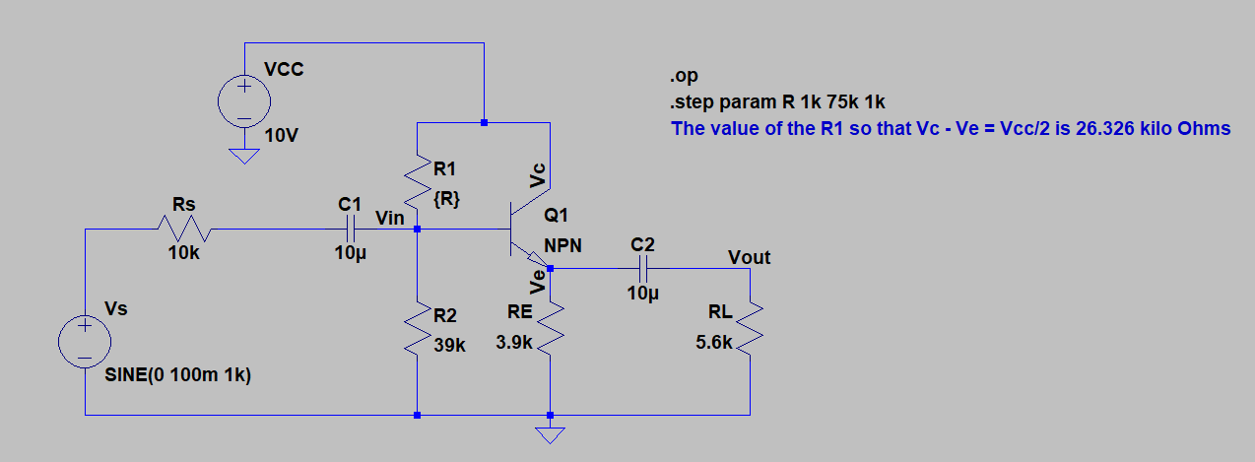

**Figure 1.1 – Common Collector Amplifier: Determination of R1**

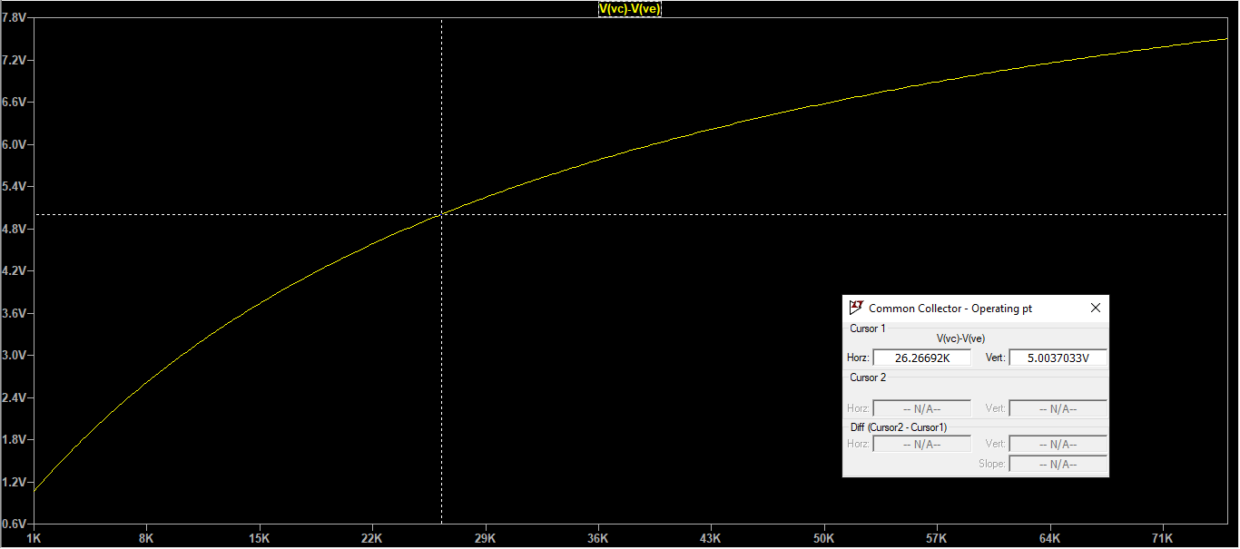

**Figure 1.2 – Common Collector Amplifier: R1 such that**

For the desired operating point (), R1 came out to be 26.326 kΩ.

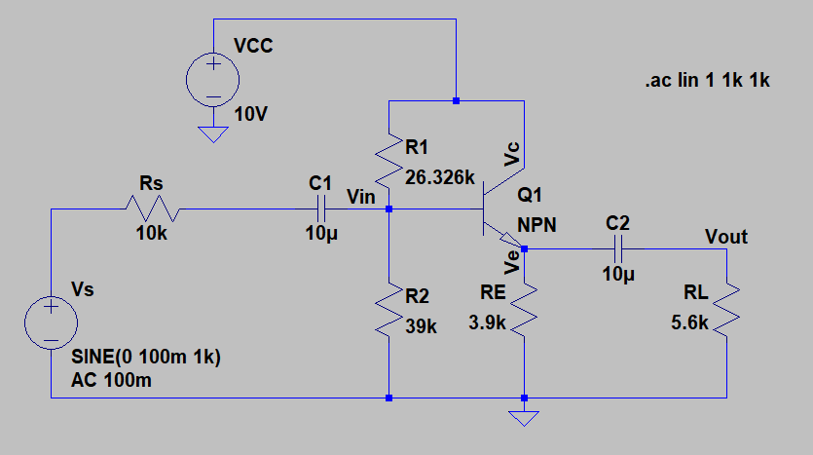

**Figure 1.3 – Common Collector Amplifier: Circuit for the determination of Vin, Vout, Iin, Iout and Rin**

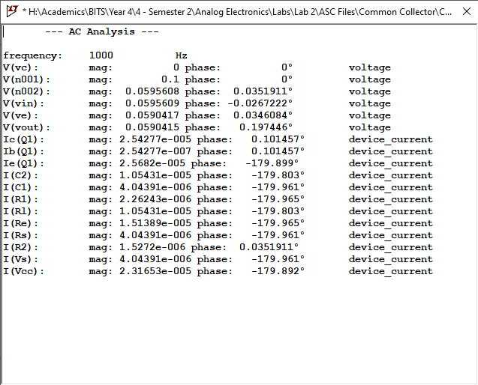

**Figure 1.4 – Common Collector Amplifier: .ac results from Figure 3**

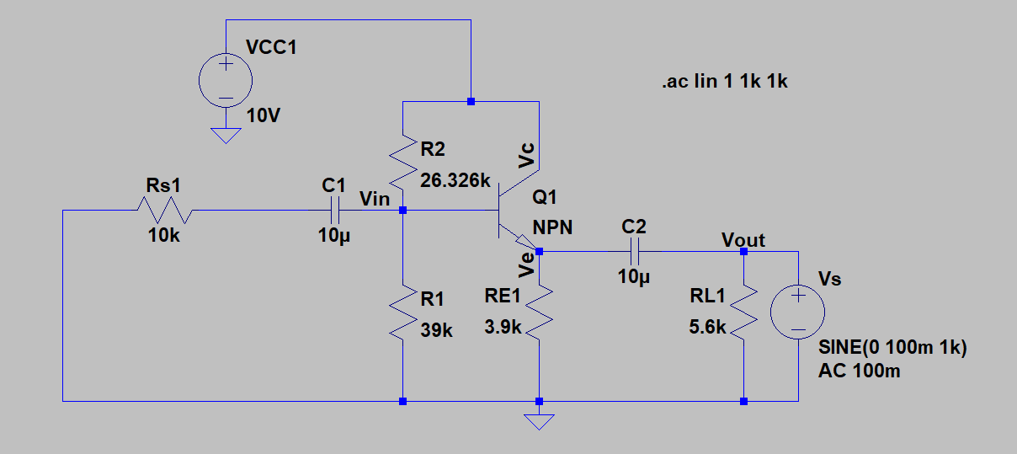

**Figure 1.5 – Common Collector Amplifier: Rout calculation**

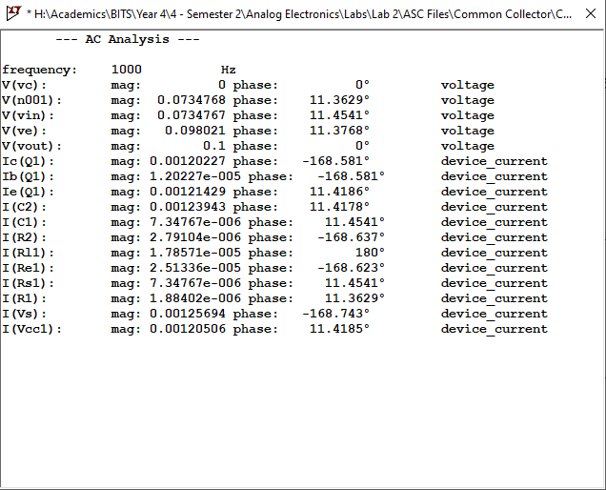

**Figure 1.6 – Common Collector Amplifier: Rout calculation as obtained from .ac analysis**

**Table 1.1 - Results Summarized for Common Collector Amplifier**

|  |  |
| --- | --- |
| Quantities to be determined | Values obtained |
| Vin | 0.0595609 V |
| Vout | 0.0590415 V |
| Iin | 4.04391 μA |
| Iout | 10.5431 μA |
| Av | 0.99127 |
| Rin | 14.728 kΩ |
| Rout | 79.55 Ω |

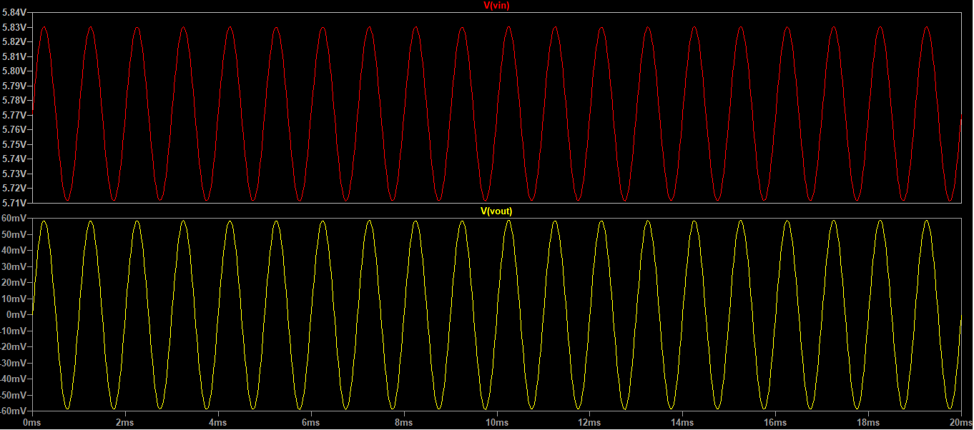

**Figure 7 – Output Waveform**

1. Darlington Configuration

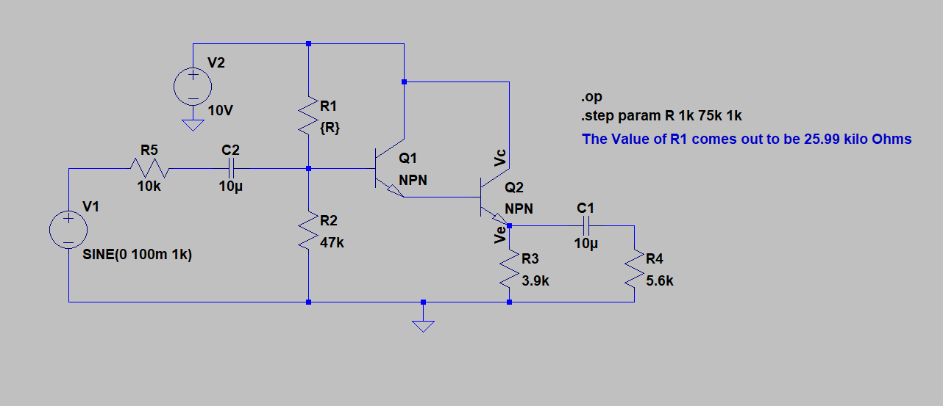

**Figure 2.1 – Darlington Configuration: Determination of R1**

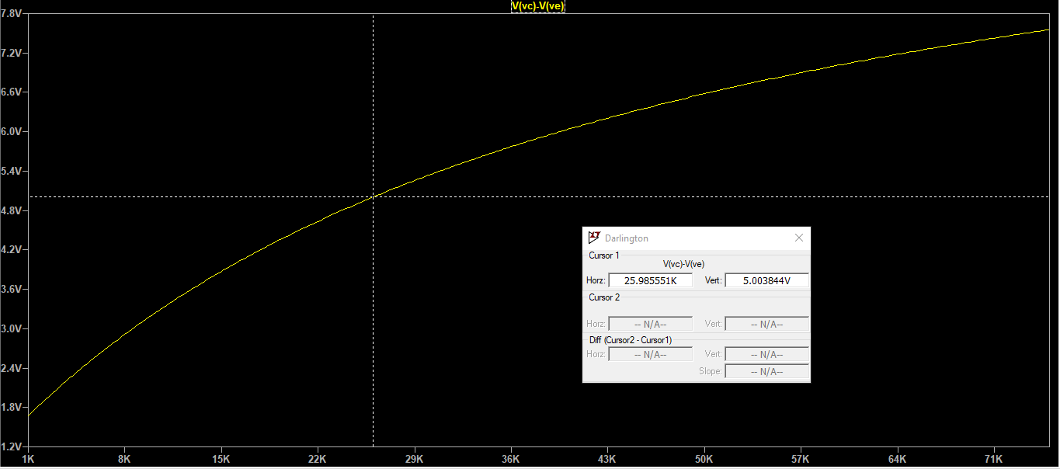

**Figure 2.2 – Darlington Configuration: R1 such that**

For the desired operating point (), R1 came out to be 25.99 kΩ.

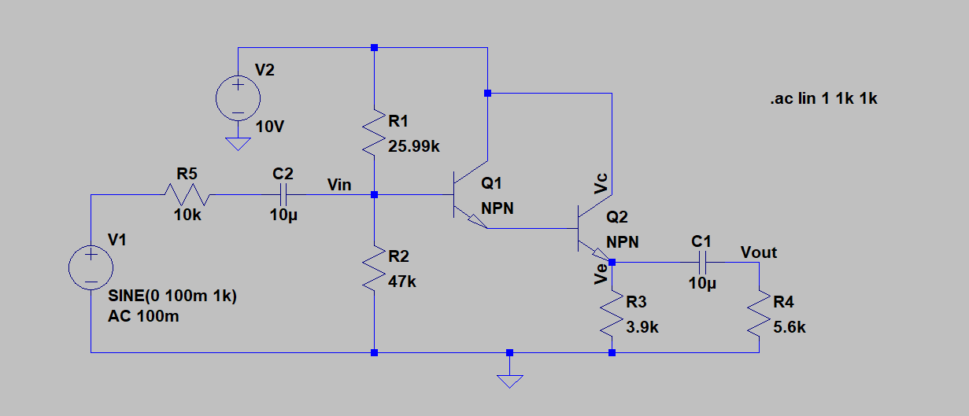

**Figure 2.3 – Darlington Configuration: Circuit for the determination of Vin, Vout, Iin, Iout and Rin**

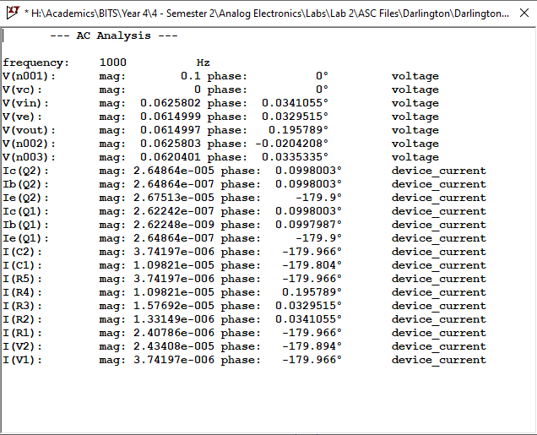

**Figure 2.4 – Darlington Configuration: .ac results from Figure 3**

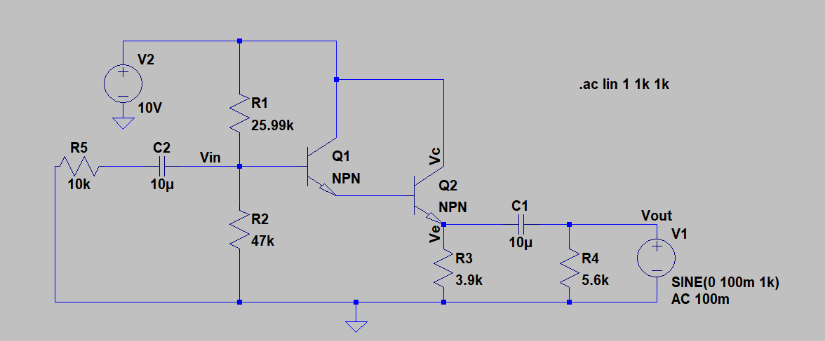

**Figure 2.5 – Darlington Configuration: Rout calculation**

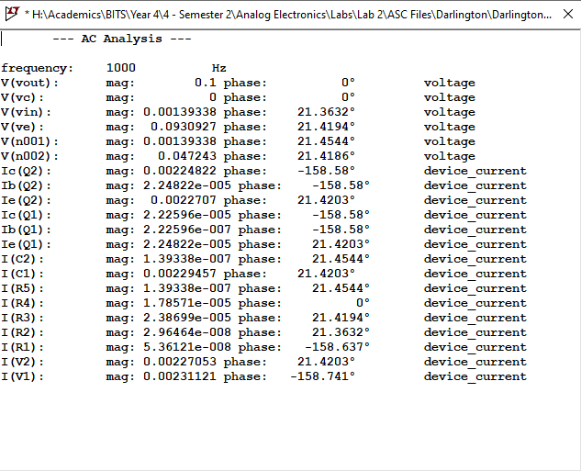

**Figure 2.6 – Darlington Configuration: Rout calculation as obtained from .ac analysis**

**Table 2.1 - Results Summarized for Darlington Configuration**

|  |  |
| --- | --- |
| Quantities to be determined | Values obtained |
| Vin | 0.0625802 V |
| Vout | 0.0614997 V |
| Iin | 3.74197 μA |
| Iout | 10.9821 μA |
| Av | 0.9827 |
| Rin | 16.724 kΩ |
| Rout | 43.26737 Ω |

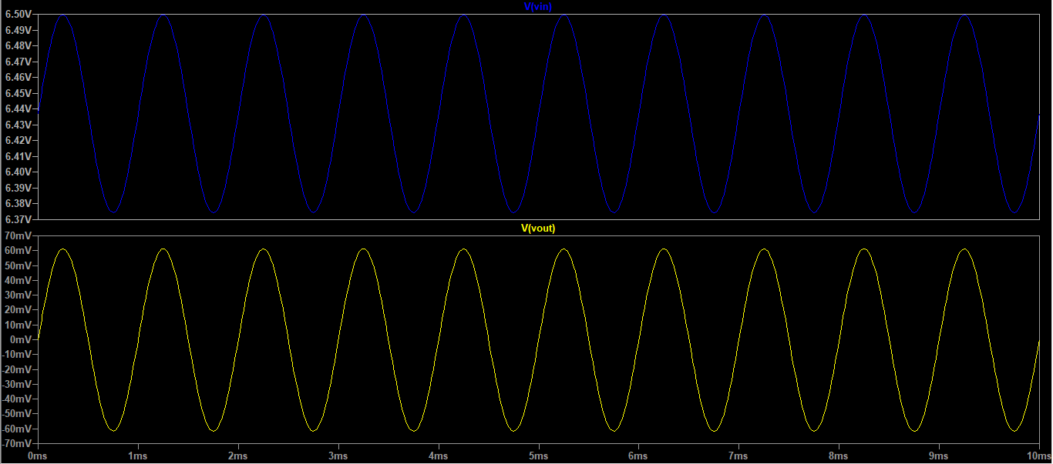

**Figure 2.7 – Output Waveform**

1. Bootstrap Configuration

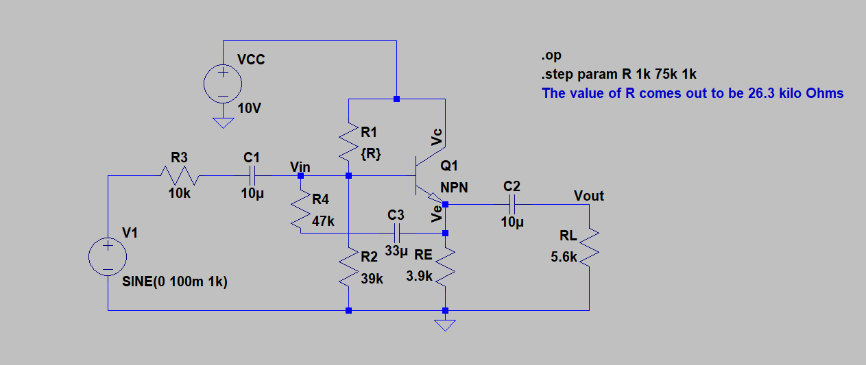

**Figure 3.1 – Bootstrap Configuration: Determination of R1**

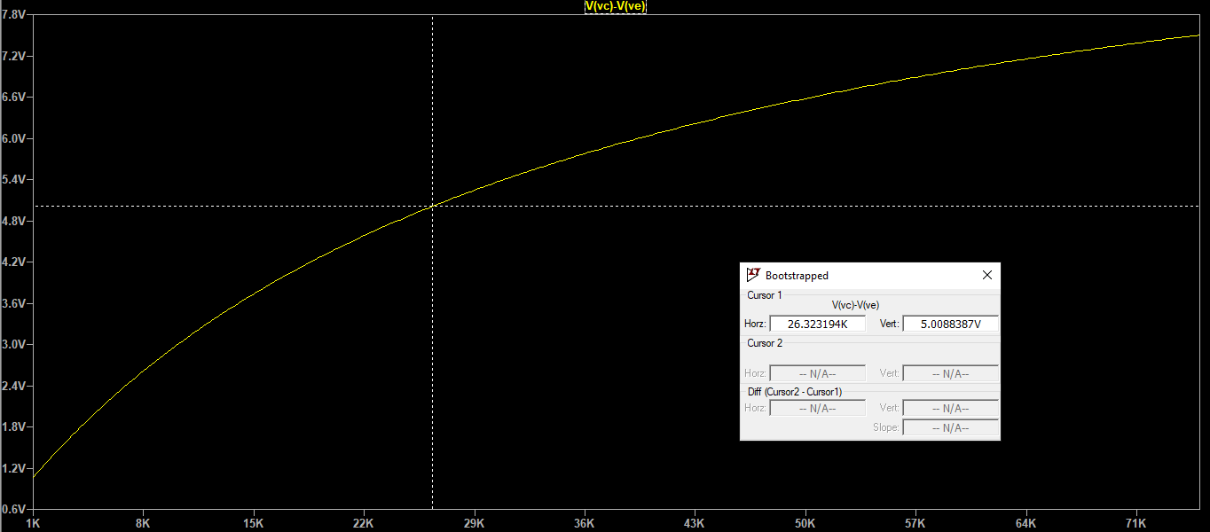

**Figure 3.2 – Bootstrap Configuration: R1 such that**

For the desired operating point (), R1 came out to be 26.323 kΩ.

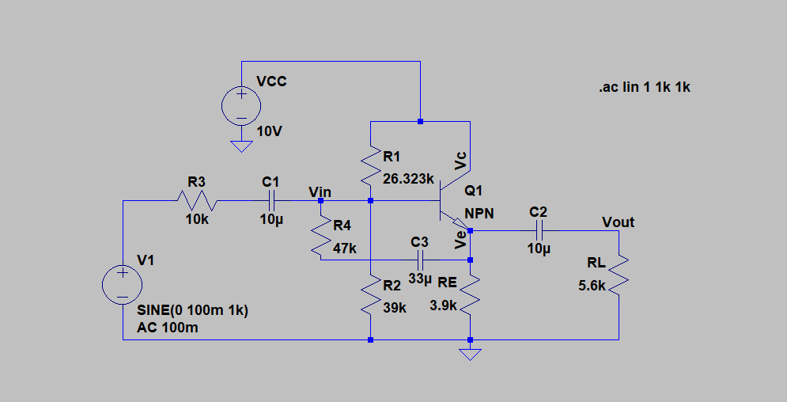

**Figure 3.3 – Bootstrap Configuration: Circuit for the determination of Vin, Vout, Iin, Iout and Rin**

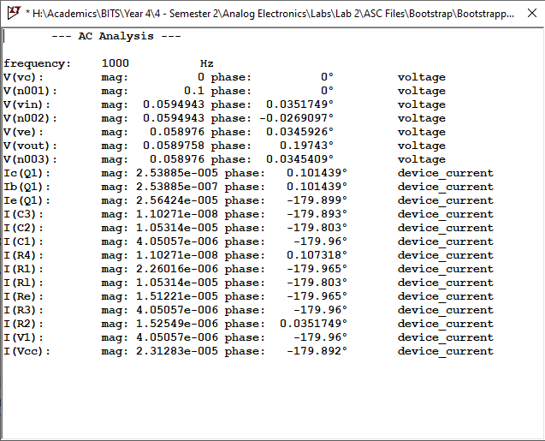

**Figure 3.4 – Bootstrap Configuration: .ac results from Figure 3**

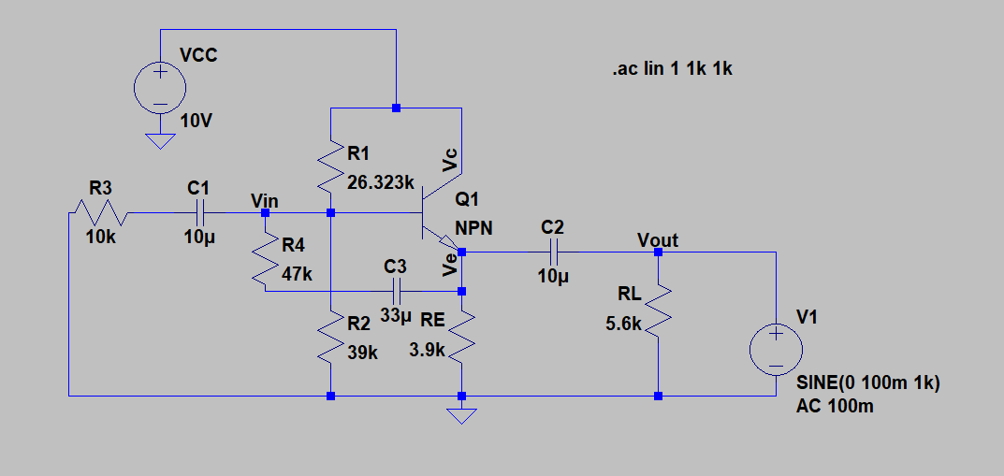

**Figure 3.5 – Bootstrap Configuration: Rout calculation**

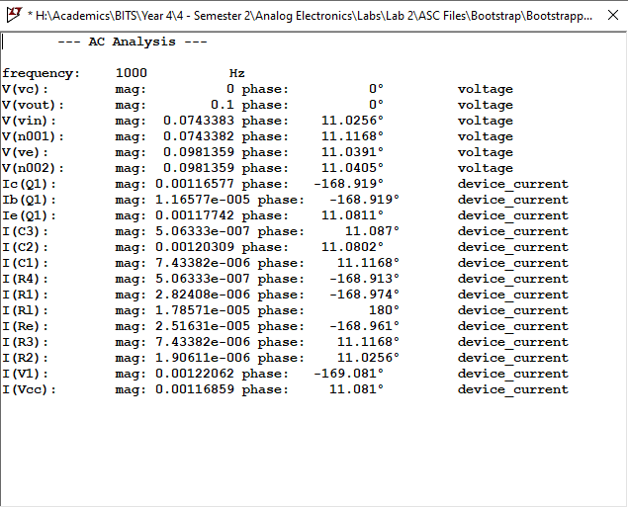

**Figure 3.6 – Bootstrap Configuration: Rout calculation as obtained from .ac analysis**

**Table 3.1 - Results Summarized for Bootstrap Configuration**

|  |  |
| --- | --- |
| Quantities to be determined | Values obtained |
| Vin | 0.0594943 V |
| Vout | 0.0589758 V |
| Iin | 4.057 μA |
| Iout | 10.5314 μA |
| Av | 0.9913 |
| Rin | 14.688 kΩ |
| Rout | 81.9255 Ω |

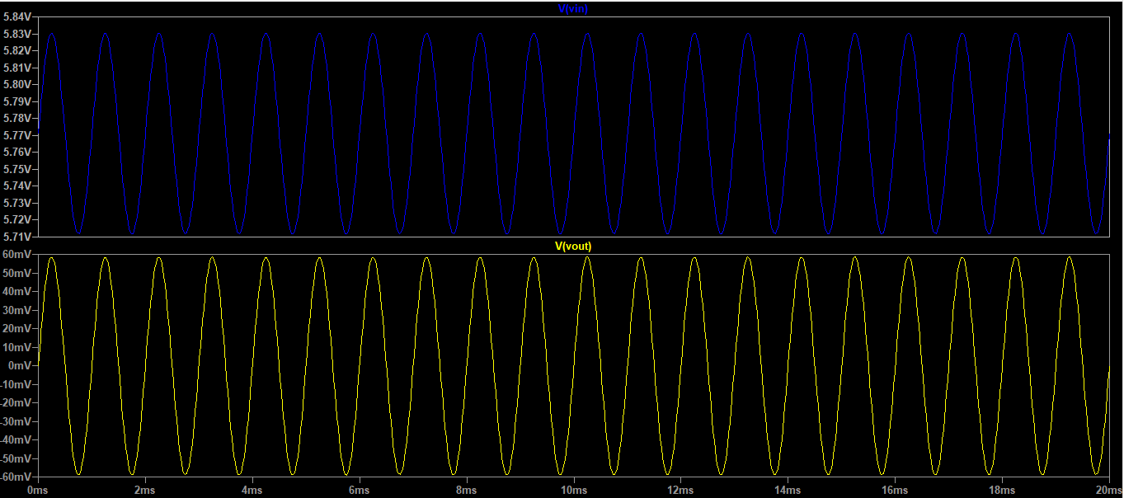

**Figure 3.7 – Output Waveform**